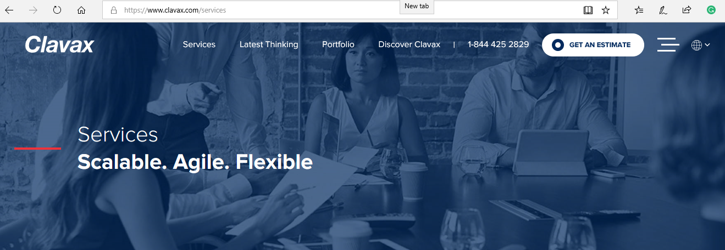

**Top Image**

<https://www.freepik.com/free-vector/landing-page-template_3518112.htm>

**Text to be used on the Image**

Digital Marketing

Branding. Advertising. Ideas.

**Next>>**

Digital marketing is a broad term used to describe the integrated marketing services used to attract, engage and convert customers online. Digital marketing uses several channels such as content marketing, influencer marketing, Search Engine Optimization, Social Media and Online advertising to help brands connect with customers and discover performance of marketing programs in real-time.

Digital marketing is also known as Internet marketing, but their real methods differ, as digital marketing is considered more targeted, measurable and interactive.

**Our Best-in-Class Services:**

**Social Media Marketing**

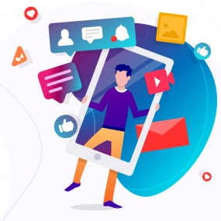

Our expert team of social media marketing will create, manage, and deliver top-performing social media campaigns for your business. As a digital marketing service provider, we position our clients to become influencers through social media marketing. Our campaigns deliver engaging content, rise followers, and drive word of mouth. This method straightforwardly translates into more leads and sales for our clients.

**Social Media Advertising**

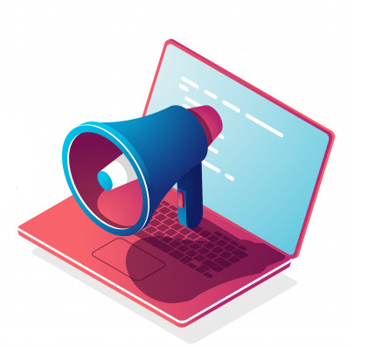

We use social media platforms to connect your product or service to thousands of people. We use highly targeted methods of social media promotion that allow our clients to locate their exact demographic and reach them at an inexpensive rate. With our social media advertising services, we will create Ads, target, and optimize them for the best results.

**Pay-Per-Click (PPC)**

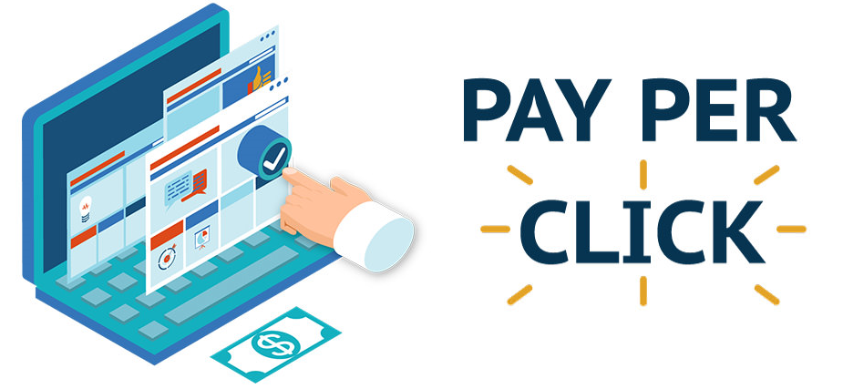

People uses places like Google, Bing & Yahoo to find related companies that meet their requirements. Search engine marketing also called as Pay-Per-Click which allows you to run advertisements on search engines that show when people are searching for the products and services you offer.

**Search Engine Optimization (SEO)**

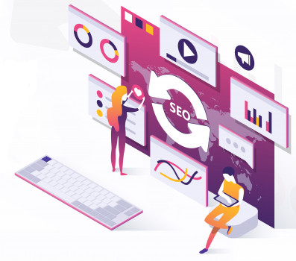

With the help of SEO technique, potential customers can find you on the search engines like Google and Bing. As a digital marketing service provider, we offer SEO services to help your website rank for the keywords most important to your business. Every day, millions of people search for the products or services you offer & we make sure they see your website when they do.

**WhatsApp Marketing**

Send unlimited Bulk WhatsApp messages to unlimited contacts and generate instant leads for your business and most importantly our software is easy to use.

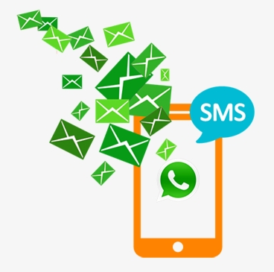

Next>>

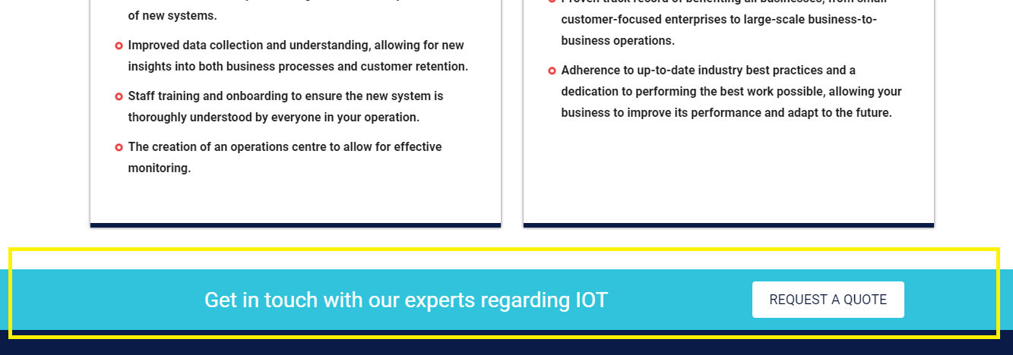

Test to be Replaced:

Want to Grow your Digital Strategy?